
SPECIALIST MATHS
TRIAL EXAMINATION 1
SOLUTIONS
2004

_____________________________________________________________________

Part I – Multiple-choice answers

1. D 7. C 13. C 19. D 25. D
2. D 8. A 14. B 20. B 26. C
3. B 9. E 15. B 21. D 27. D
4. E 10. E 16. C 22. C 28. D
5. A 11. D 17. B 23. D 29. B
6. A 12. D 18. C 24. D 30. A
___________________________________________________________________________

Part I- Multiple-choice solutions

Question 1
The graph of 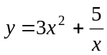 has a vertical asymptote given by 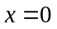. Its other asymptote is given by 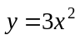 so reject option E. The graph has a local minimum where 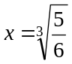 and not where 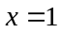so reject option B. The graph is defined for 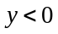 so reject option C.
Also, the graph has an x-intercept but not at 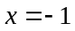 so reject option A.
Only option D is correct since is an asymptote and hence there are no y-intercepts.
The answer is D.

Question 2
The graph of the relation 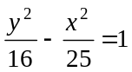 is the hyperbola shown below.
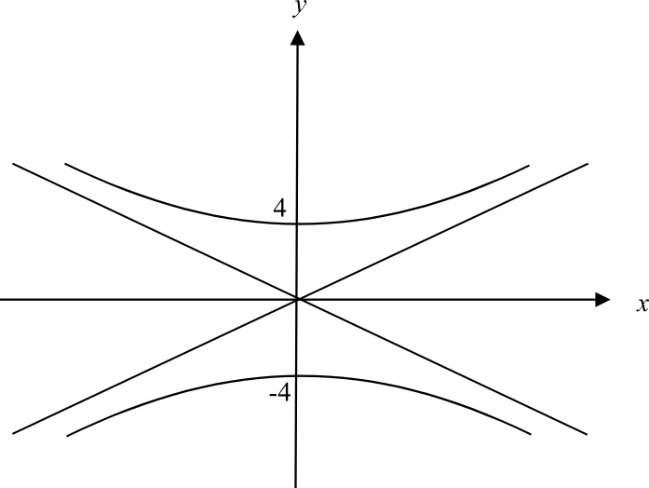

It intersects with the y-axis twice.
The answer is D.
Question 3
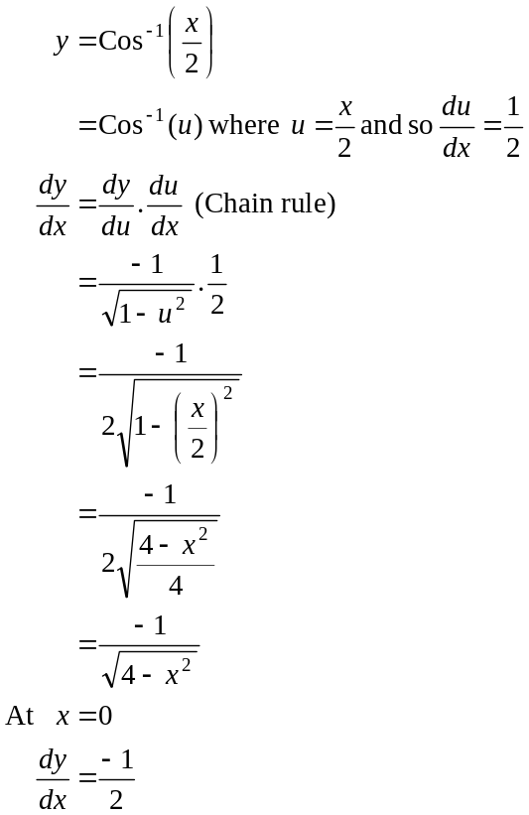

The answer is B.

Question 4

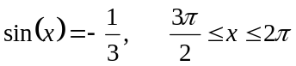
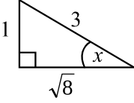
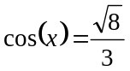 since in the fourth quadrant cos is positive
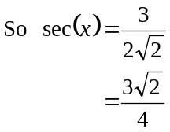
The answer is E.

Question 5
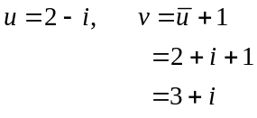
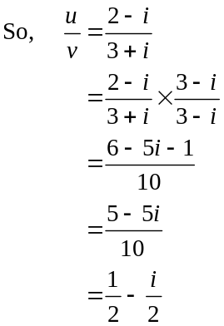
The answer is A.

Question 6
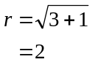
Note that the question asks for “a” polar form.
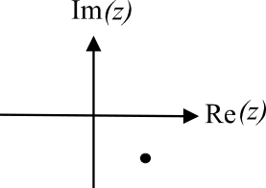
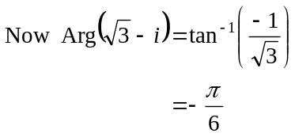
(in 4th quadrant)
This is the value of Arg(z) in the range 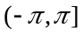.
So a polar form of 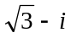 could be 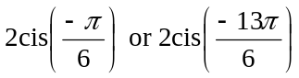 and so on.
In this case the only correct option is A.
The answer is A.

Question 7
We have a semicircle.
Now 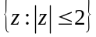 describes a circle with radius 2 units.
Also, 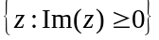 describes the top half of the complex plane including the real axis.
Hence 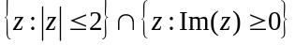 describes the semicircle we have. Note that 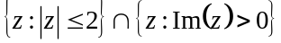 is close but excludes the Real axis between –2 and 2 which is included in the diagram.
The answer is C.

Question 8
Since 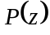 is a cubic polynomial with real coefficients and one of its solutions is 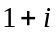 then another of its solutions must be 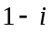, that is, the conjugate of (conjugate root theorem). The other solution must be real.
Note that 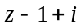 is a factor not a solution, as is 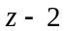.
The only feasible answer is 3.
The answer is A.

Question 9

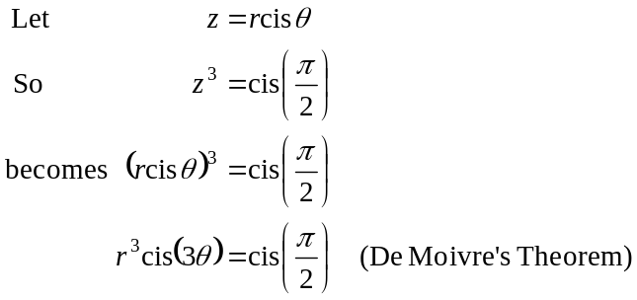
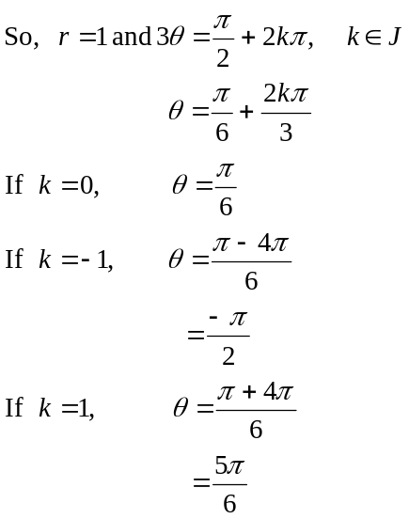

So the three solutions are 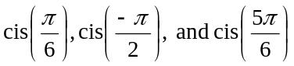.
The answer is E.

Question 10

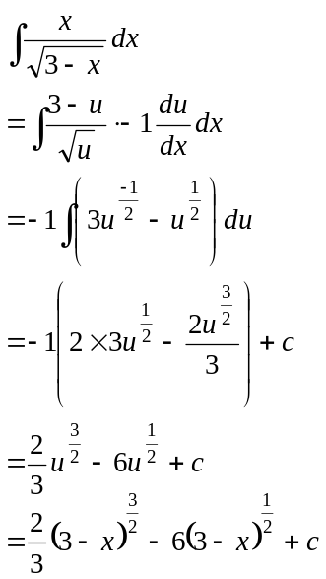
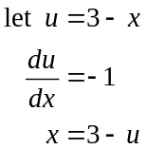
Note “an antiderivative” means c takes on a particular value. In this case c = 0.
The answer is E.

Question 11

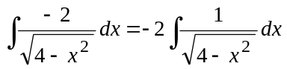
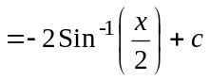
OR

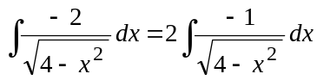
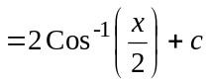
Only the second answer is offered.
The answer is D.

Question 12

With the integration techniques available to us in this course, we are not able to antidifferentiate 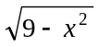.
Use a graphics calculator instead.
The answer, correct to 4 decimal places is 8.4633.
The answer is D.

Question 13

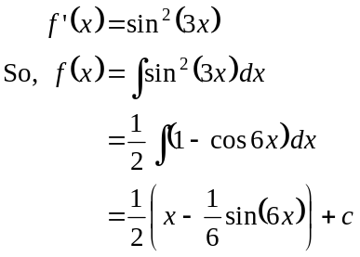
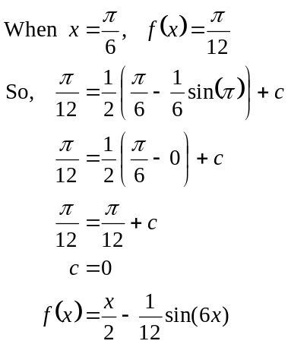
The answer is C.

Question 14

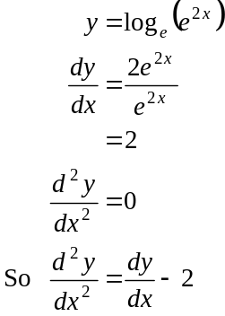

Alternatively,
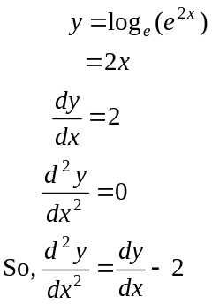

The answer is B.

Question 15
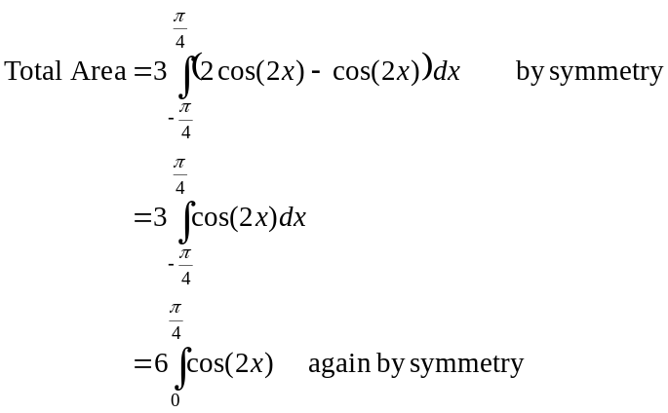
Note that in option D, the second term should be negative and similarly in option E.
The answer is B.

Question 16

On the graph of 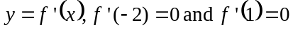. So at 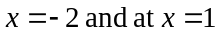 on the graph of 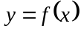 we have a stationary point.
For 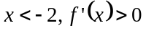 and for 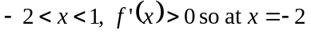 on the graph of , we must have a stationary point of inflection.
For on the graph of , we must have a local maximum.
There cannot be a stationary point of inflection at 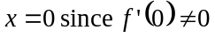.
The answer is C.

Question 17

Using the formula sheet, we have, if 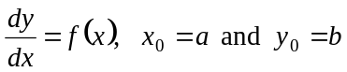,
then
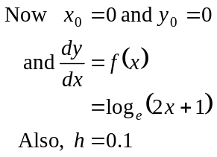
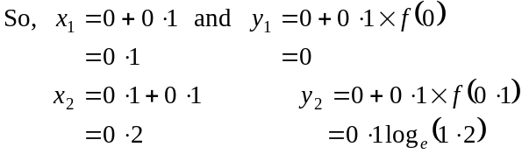
So, when 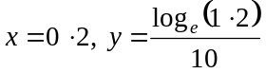
The answer is B.

Question 18

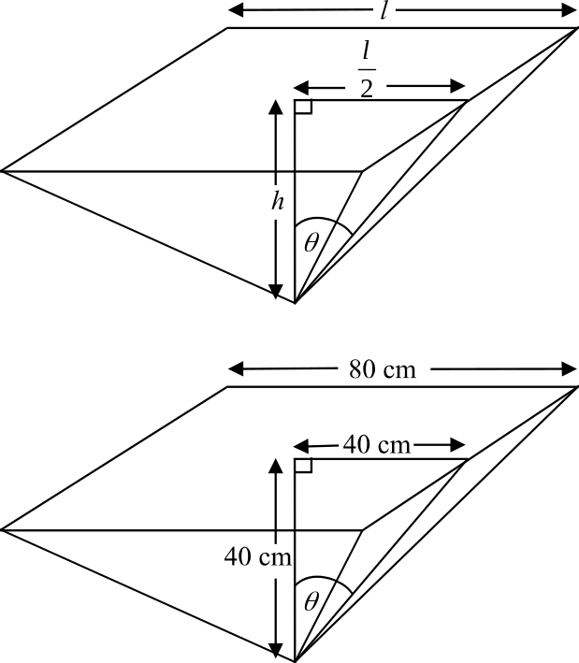

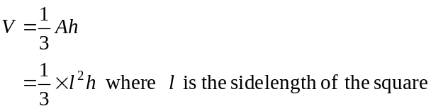
In the triangle drawn, 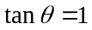
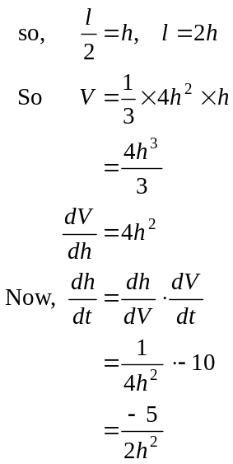
The answer is C.

Question 19

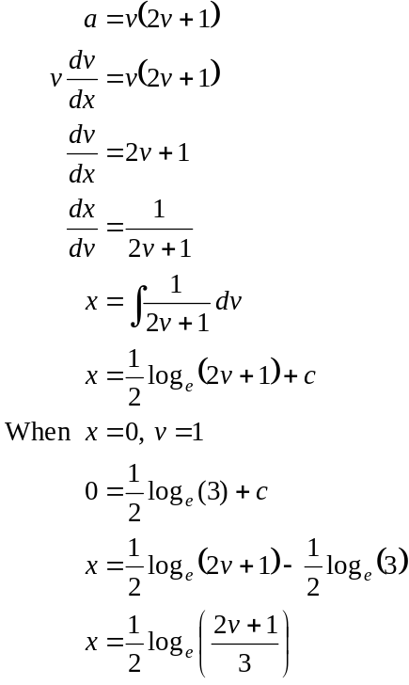
The answer is D.

Question 20

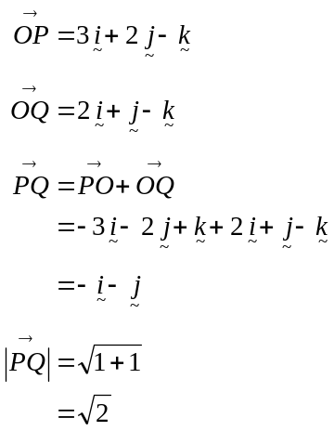
The answer is B.

Question 21

Note that since the surveyor is travelling up at a gradient of 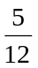 he won't travel 100 m in the 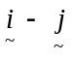 plane.
Consider the vertical component.

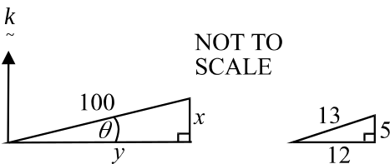

From the diagram we have 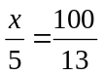 since the triangles are similar.
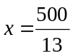

Also note from the diagram that 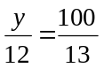
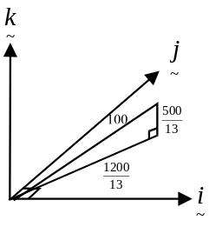
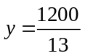
This is the distance travelled in the plane.

In the plane,
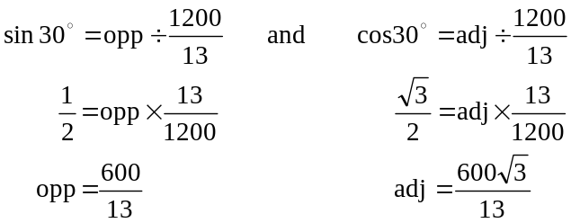
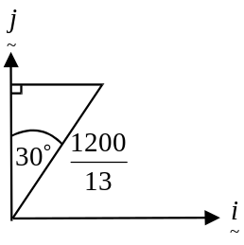

So 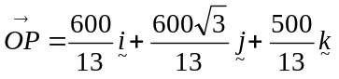
The answer is D.

Question 22
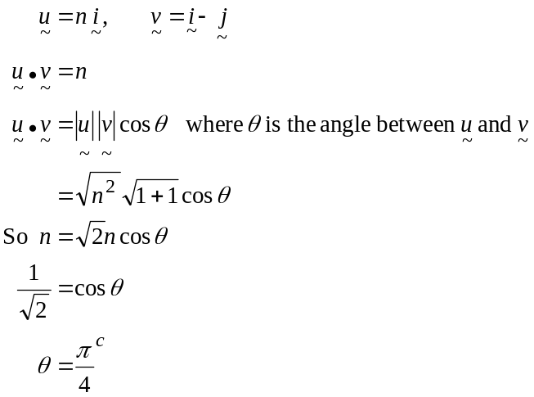
The answer is C.

Question 23
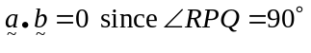.
So option A is correct.
Option B is correct. (triangle rule for addition of vectors)
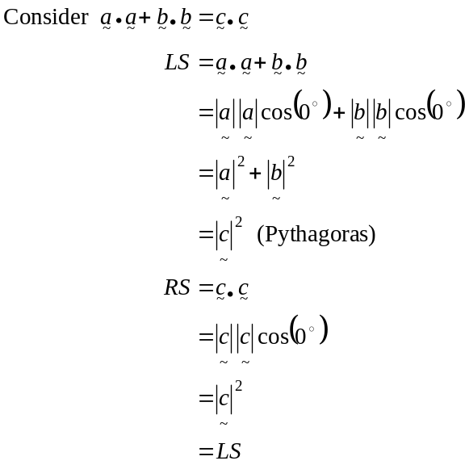
So option C is correct.
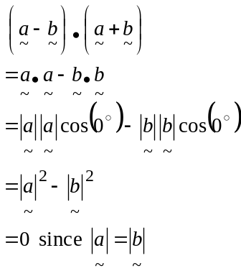
So option D is incorrect. Option E is correct since the sum of side lengths PR and PQ must be greater than sidelength QR. The answer is D.

Question 24

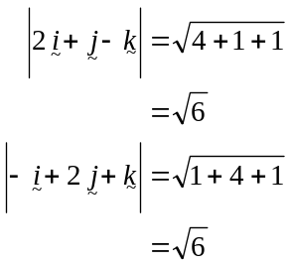
Now the vector resolute of perpendicular to is 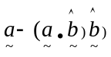.
So, the vector resolute of 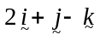 perpendicular to 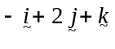 is
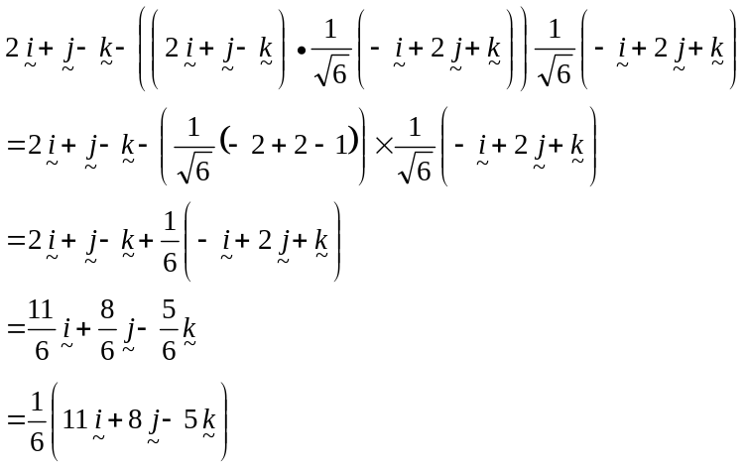
The answer is D.

Question 25

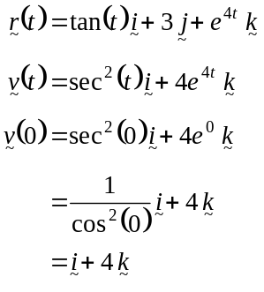
The motion of the particle initially is in the direction of 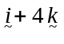.
The answer is D.

Question 26

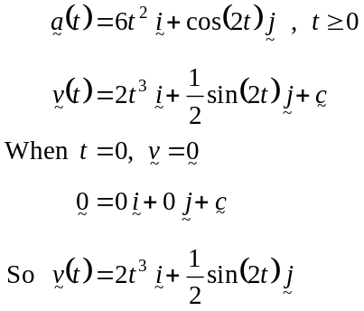
The momentum of the particle, 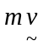, is given by
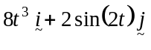
Note that momentum is a vector quantity.
The answer is C.

Question 27

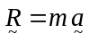
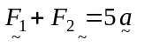
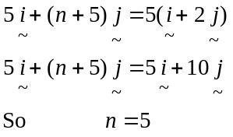
The answer is D.

Question 28

The box is stationary.
Resolving horizontally, we have
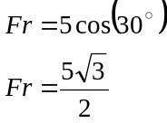
So options A and C are not correct.
Note, since the box is not on the point of moving across the table,
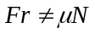
In fact 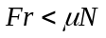.
So option D is correct.
Resolving vertically, we have
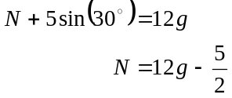
So option B and option E are incorrect.
The answer is D.

Question 29

The gravitational forces acting on each particle are 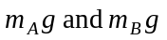. This eliminates options A and D.
The friction forces act in the opposite direction to the force F. This eliminates option E. The tension force in the connection runs in both directions. This eliminates option C.
Only option B shows all forces correctly.
The answer is B.

Question 30

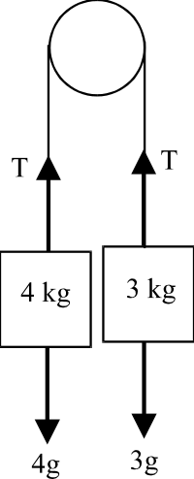

Around the 3kg box.

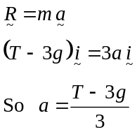
The answer is A.
PART II

Question 1

When George finally passes the stationary red car, each has covered the same distance since George was originally overtaken.
Let the original speed of the red car be v.
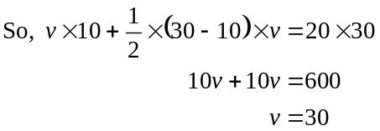
(1 mark)
The red car was travelling at 30 m/s.

(1 mark)

Question 2

- The 6 solutions to the equation 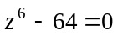 are spaced evenly around a circle with radius 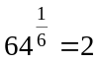. Since one has already been given to us the others must be spaced at intervals of 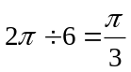 apart as indicated in the diagram below.

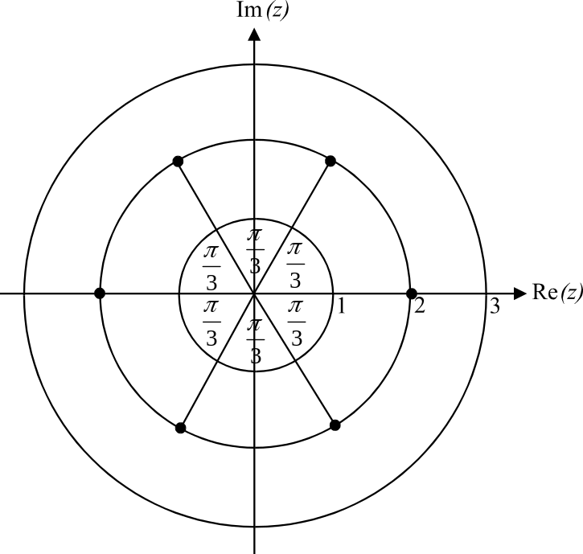

(1 mark)

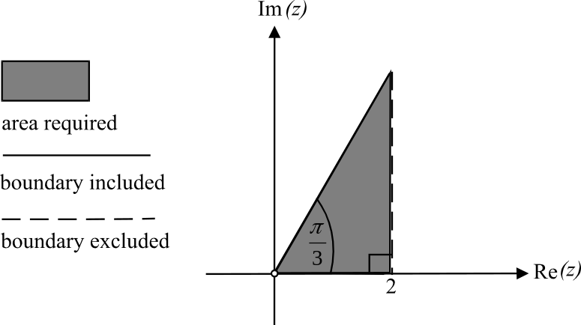

(1 mark) correct area
(1 mark) correct boundaries

Question 3
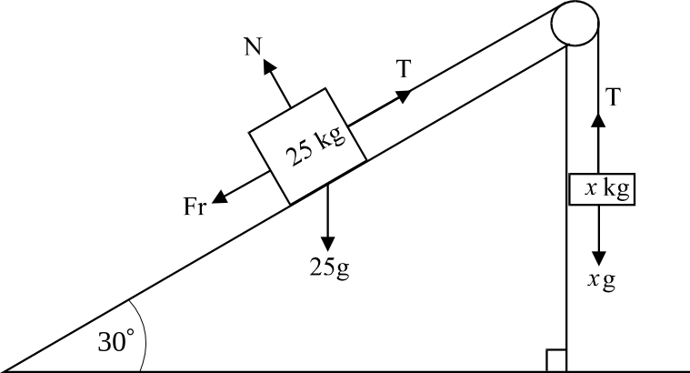

(1 mark)
b. The system is at the point of moving so 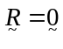.

Resolving around the 25kg object we have
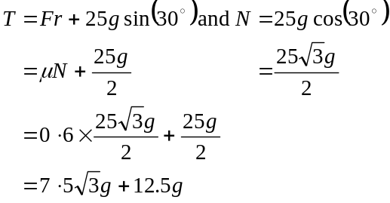
(1 mark) for correct resolution
(1 mark)
Resolving around the x kg object we have
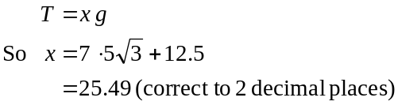
(1 mark)
Question 4
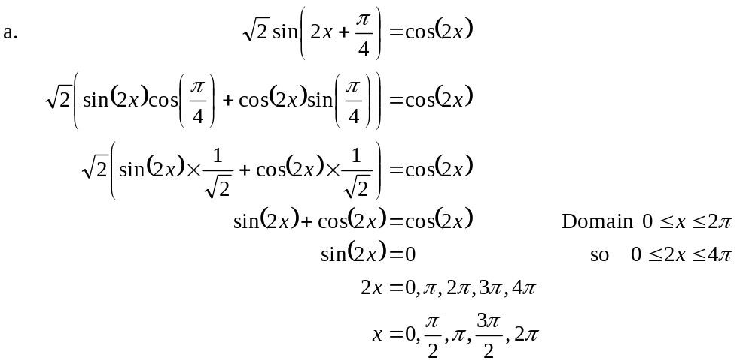
(1 mark)
(1 mark)

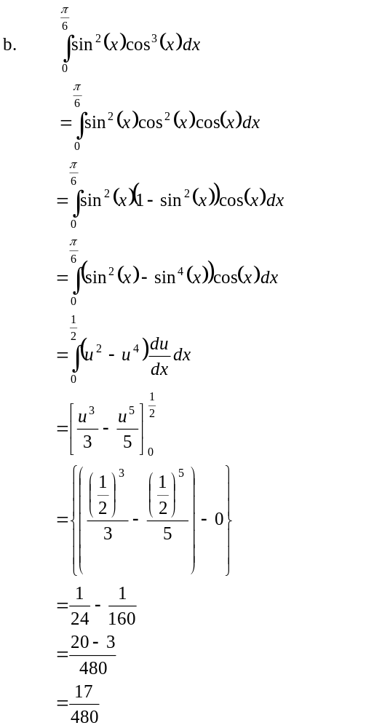
(1 mark) for integrand
(1 mark) for terminals
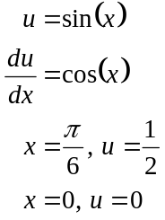
(1 mark)
(1 mark)
Question 5

- Area required
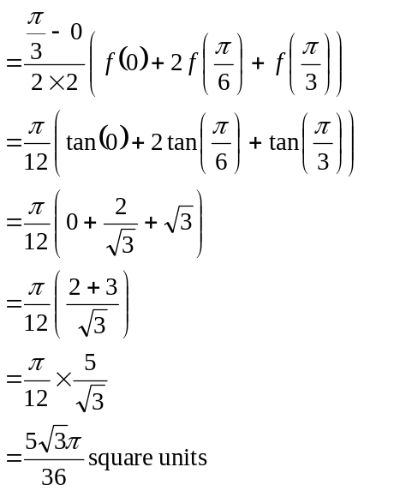
(1 mark)
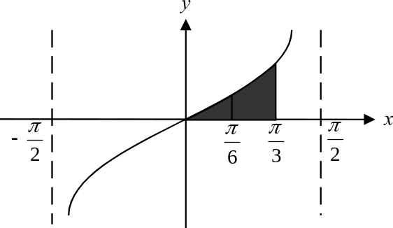
(1 mark)
- Draw a diagram.
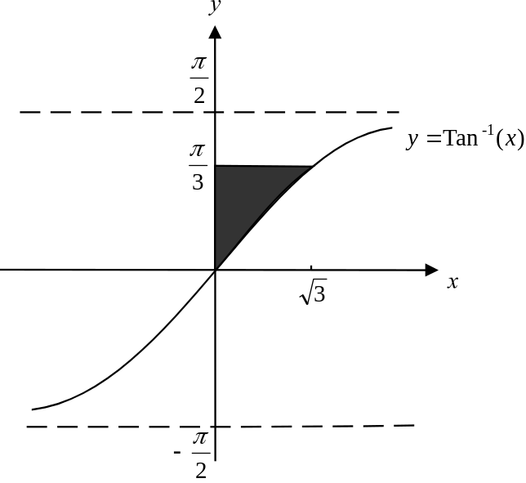

The shaded area above is equal to the shaded area shown in the diagram below on the graph of its inverse function, 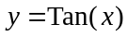.
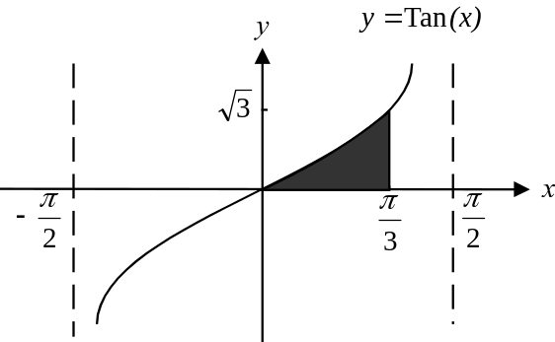

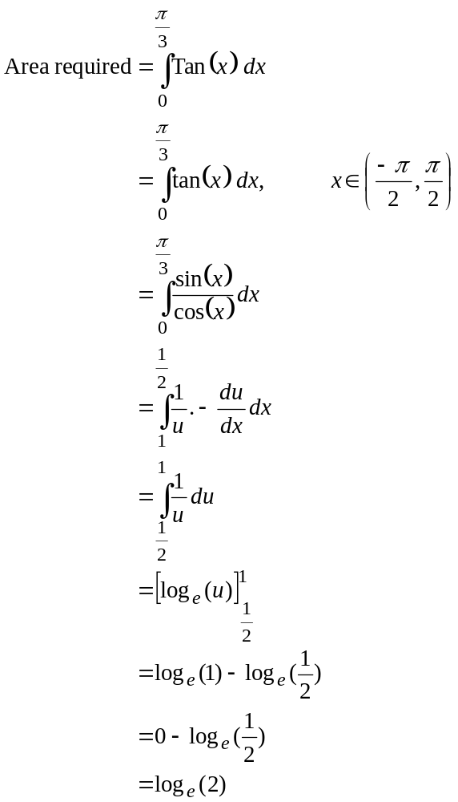
(1 mark)
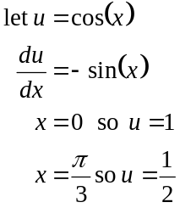
(1 mark)
Area required is 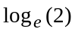 square units. (1 mark)

(Do NOT express this answer as a decimal approximation since you have been asked for an exact value. Also, if you have time, check your answer using your graphics calculator.)

Total 20 marks

